Mystery Writing
Narrative Writing Unit

The students will follow the writing process and the format adopted by CCBOE to teach writing with Sarah Cordova’s framework.

2015-2016
Lynn Carswell and Sarah Kniphfer

2015-2016

Day 1 | Immersion Teaching Point #1: I can recognize a mystery.  Mentor Text(s): The Web Files by Margie Palatini  Student Handout(s): Ingredients for a Mystery http://teacher.scholastic.com  Anchor Chart:  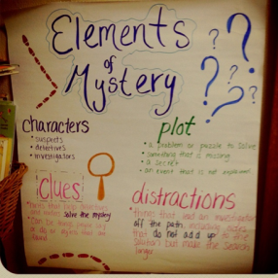
I Do | Review: (1 min.) “Today writers, we are going to be thinking about and exploring the genre of Mysteries.”  Demonstrate/Model: (5-7 min.)  Like all narratives, mysteries include character, setting, and plot. These also have clues, problem and solution and sometimes red herrings. Pass out and review the handout Ingredients for a Mystery. Listen to the story; point out the examples from the text.
We Do | Guided Practice: (3-5 min.)  Begin to review the elements of the story. The teacher and students complete the characters, setting, and plot together.
You Do | Students will: (20-30 min.)  Use the handout and check off the ingredients (clues, red herrings, and recipe for a mystery) found in the mystery as you discuss them with your partner.
English Language Arts Georgia Standards of Excellence: | ELAGSE4RL3 Describe in depth a character, setting, or event in a story or drama, drawing on specific details in the text (e.g., a character’s thoughts, words, or actions).  ELAGSE4RL1 Refer to details and examples in a text when explaining what the text says explicitly and when drawing inferences from the text.  ELAGSE4RL9 Compare and contrast the treatment of similar themes and topics (e.g., opposition of good and evil) and patterns of events (e.g., the quest) in stories, myths, and traditional literature from different cultures.  ELAGSE4SL1 Engage effectively in a range of collaborative discussions (one-on-one, in groups, and teacher-led) with diverse partners on grade 4 topics and texts, building on others’ ideas and expressing their own clearly.

Day 2 | Immersion Teaching Point #2: I can use mystery words in my writing.  Mentor Text(s): Private I. Guana on www.storylineonline.net  Student Handout(s): The Detective’s Dictionary, Detective Words Concentration Game (one copy for each two students) http://teacher.scholastic.com  Anchor Chart: http://media-cache-ec0.pinimg.com/736x/8d/ca/d6/8dcad6a0e84667b28c727a8fba1718b8.jpg  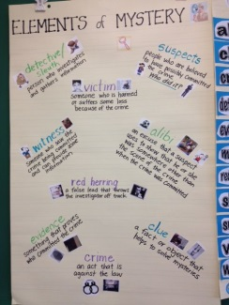
I Do | Review: (1 min.)  “Yesterday, we began exploring the elements that writers use when writing a mystery. Today we will look for the specific vocabulary that good mystery writer’s use.”  Demonstrate/Model: (5-7 min.)  Pass out and review the genre specific vocabulary from the Handout.  Listen to the story; point out the examples of the vocabulary as used in the text.
We Do | Guided Practice: (3-5 min.)  Play a concentration game with partners of the genre specific vocabulary words.
You Do | Students will: (20-30 min.)  Choose four – five of the genre specific vocabulary and use the words in a complete sentence using evidence from the text.
English Language Arts Georgia Standards of Excellence: | ELAGSE4RL4 Determine the meaning of words and phrases as they are used in a text, including those that allude to significant characters found in mythology (e.g., Herculean).  ELAGSE4RL9 Compare and contrast the treatment of similar themes and topics (e.g., opposition of good and evil) and patterns of events (e.g., the quest) in stories, myths, and traditional literature from different cultures.  ELAGSE4SL1 Engage effectively in a range of collaborative discussions (one-on-one, in groups, and teacher-led) with diverse partners on grade 4 topics and texts, building on others’ ideas and expressing their own clearly.

Day 3 | Immersion Teaching Point #3: I can identify elements in a mystery.  Mentor Text(s): The Case of the Ruined Roses  Student Handout(s): The Case of the Ruined Roses (attached) and Suspect List  http://teacher.scholastic.com  Anchor Chart: Google Pinterest Question Chart  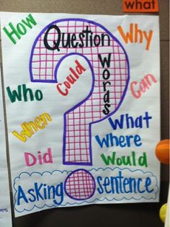
I Do | Review: (1 min.)  We have explored the elements that writers use when writing a mystery and the specific vocabulary that good mystery writer’s use. Today we will focus on the use of suspects to make a mystery intriguing.  Demonstrate/Model: (5-7min.)  Pass out, The Case of the Ruined Roses, story handout and read aloud with the students. Discuss the importance of suspects to make a mystery intriguing.
We Do | Guided Practice: (3-5 min.)  Pass out the Suspect List handout and discuss one suspect with the students, then students complete the handout with a partner of the other suspects in the story.
You Do | Students will: (20-30 min.)  The students will work with a partner to identify the setting, character, plot, clues, and red herring. The students will use the following coloring code to underline the elements on their handout.  Setting = Blue  Characters = Green  Plot = Purple  Clues = Orange  Red herring = Red
English Language Arts Georgia Standards of Excellence: | ELAGSE4RL4 Determine the meaning of words and phrases as they are used in a text, including those that allude to significant characters found in mythology (e.g., Herculean).  ELAGSE4RL9 Compare and contrast the treatment of similar themes and topics (e.g., opposition of good and evil) and patterns of events (e.g., the quest) in stories, myths, and traditional literature from different cultures.  ELAGSE4SL1 Engage effectively in a range of collaborative discussions (one-on-one, in groups, and teacher-led) with diverse partners on grade 4 topics and texts, building on others’ ideas and expressing their own clearly.

Day 4 | Immersion Teaching Point #4: I can identify elements in a mystery.  Mentor Text(s): The Missing Mitten Mystery by Steven Kellogg  Student Handout(s): Detective Case Report http://teacher.scholastic.com  Anchor Chart:  http://media-cacheak0.pinimg.com/736x/f9/7b/9a/f97b9a1a8ab06b24592ff06d4954f20d.jpg  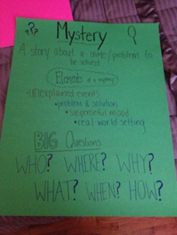
I Do | Review: (1 min.)  We have explored the elements that writers use when writing a mystery and the specific vocabulary that good mystery writer’s use. Today we will focus on the purpose of mysteries.  Demonstrate/Model: (5-7 min.)  Read the story aloud to the students. Discuss the author’s purpose in writing the story. Discuss the intended audience.
We Do | Guided Practice: (3-5 min.)  Discuss with a partner or group the following questions:  1. Who were the suspects in the story? Detectives?  2. What was the setting of the story?  3. What are some of the clues that occurred in the story?  4. Which character discovered the clue?  5. Did the story have a red herring?  6. How did the mystery get resolved?  7. What evidence helped solve the mystery?
You Do | Students will: (20-30 mins.)  Independently complete the Detective Case Report handout using the information gathered during the partner discussion.
English Language Arts Georgia Standards of Excellence: | ELAGSE4RL4 Determine the meaning of words and phrases as they are used in a text, including those that allude to significant characters found in mythology (e.g., Herculean).  ELAGSE4RL9 Compare and contrast the treatment of similar themes and topics (e.g., opposition of good and evil) and patterns of events (e.g., the quest) in stories, myths, and traditional literature from different cultures.  ELAGSE4SL1 Engage effectively in a range of collaborative discussions (one-on-one, in groups, and teacher-led) with diverse partners on grade 4 topics and texts, building on others’ ideas and expressing their own clearly.

Day 5 | Immersion Teaching Point #5: I can identify the elements in a mystery.  Mentor Text(s): Nate the Great and the Stolen Base  Student Handout(s): List of Nate the Great Titles (projected onto screen)  Anchor Chart: https://www.pinterest.com/explore/prediction-anchor-chart/  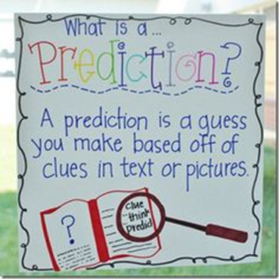
I Do | Review: (1 min.)  We have explored the elements that writers use when writing a mystery and the specific vocabulary that good mystery writer’s use. We have also talked about the purpose that writers use for writing mysteries. Today we will read a book from a series of mysteries.  Demonstrate/Model: (5-7 min.)  Read the book aloud. Discuss why the author writes mysteries and chose this genre for her series. Provide the students with a list of Nate the Great titles. Teacher chooses one title and writes three sentences predicting the story based on the title.
We Do | Guided Practice: (3-5 min.)  With a partner choose a title from the list and discuss your prediction, justify your prediction using clues from the title.
You Do | Students will: (20-30 min.)  Write three to five sentences independently after choosing one title from the list.
English Language Arts Georgia Standards of Excellence: | ELAGSE4RL4 Determine the meaning of words and phrases as they are used in a text, including those that allude to significant characters found in mythology (e.g., Herculean).  ELAGSE4RL9 Compare and contrast the treatment of similar themes and topics (e.g., opposition of good and evil) and patterns of events (e.g., the quest) in stories, myths, and traditional literature from different cultures.  ELAGSE4SL1 Engage effectively in a range of collaborative discussions (one-on-one, in groups, and teacher-led) with diverse partners on grade 4 topics and texts, building on others’ ideas and expressing their own clearly.

Day 6 | Generating Ideas Teaching Point #1: I can write a mystery about stolen property.  Mentor Text(s): Nate the Great and the Stolen Base  Student Handout(s): NONE  Anchor Chart: https://www.pinterest.com/pin/365284219751768973/  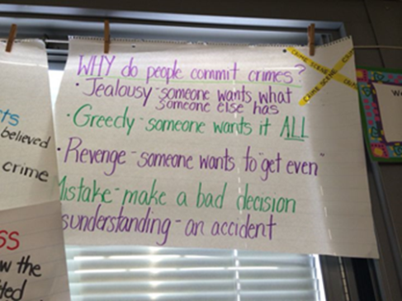
I Do | Review: (1 min.)  We have explored the elements that writers use when writing a mystery and the specific vocabulary that good mystery writer’s use. We have also talked about the purpose that writers use for writing mysteries. Today we will focus on a common theme used in many mysteries: stolen property.  Demonstrate/Model: (5-7 min.)  Discuss the mentor text Nate the Great and the Stolen Base and the item that was stolen. Review the anchor chart on why criminals commit crimes. The teacher chooses an item that could be stolen and writes a paragraph about the crime. Point out that this is the plot of a mystery.
We Do | Guided Practice: (3-5 min.)  Discuss any experience that you have with stolen property with your partner. Make up a short mystery story about possible stolen property.
You Do | Students will: (20-30 min.)  Write a paragraph about stolen items. (If student finishes early, then they can write a second paragraph about another stolen item.)
English Language Arts Georgia Standards of Excellence: | ELAGSE4W5 With guidance and support from peers and adults, develop and strengthen writing as needed by planning, revising, and editing. (Editing for conventions should demonstrate command of Language Standards 1–3 up to and including grade 4.)  ELAGSE4W3 Write narratives to develop real or imagined experiences or events using effective technique, descriptive details, and clear event sequences.

Day 7 | Generating Ideas Teaching Point #2: I can write a mystery about misplaced property.  Mentor Text(s): The Missing Mitten Mystery by Steven Kellogg  Student Handout(s): NONE  Anchor Chart:  http://media-cacheak0.pinimg.com/736x/f9/7b/9a/f97b9a1a8ab06b24592ff06d4954f20d.jpg  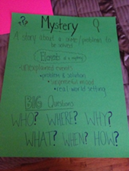
I Do | Review: (1 min.)  We have explored the elements that writers use when writing a mystery and the specific vocabulary that good mystery writer’s use. We have also talked about the purpose that writers use for writing mysteries. Yesterday we focused on a common theme used in many mysteries: stolen property. Today we will focus on misplaced property.  Demonstrate/Model: (5-7 min.)  Discuss the mentor text, The Missing Mitten Mystery, and the item that was misplaced. The teacher chooses an item that could be misplaced and writes a paragraph about the event. Point out that this is the plot of a mystery.
We Do | Guided Practice: (3-5 min.)  Discuss any experience that you have with misplaced property with your partner. Make up a short mystery story about possible misplaced property.
You Do | Students will: (20 – 30 min.)  Write a paragraph about a misplaced item. (If student finishes early, then they can write a second paragraph about another stolen item.)
English Language Arts Georgia Standards of Excellence: | ELAGSE4W5 With guidance and support from peers and adults, develop and strengthen writing as needed by planning, revising, and editing. (Editing for conventions should demonstrate command of Language Standards 1–3 up to and including grade 4.)  ELAGSE4W3 Write narratives to develop real or imagined experiences or events using effective technique, descriptive details, and clear event sequences.
Day 8 | Selecting Teaching Point #1: I can choose a crime for my mystery!  Mentor Text(s): Review All previous texts.  Student Handout(s): Selecting Worksheet (Sarah Cordova)  Anchor Chart: We’re Going Public! Chart https://drive.google.com/file/d/0B33A_tcmOmXpTHN3MmJaajgwTkk/view?pli=1
I Do | Review: (1 min.)  We have explored the elements that writers use when writing a mystery and the specific vocabulary that good mystery writer’s use. We have also talked about the purpose that writers use for writing mysteries. We focused on a common theme used in many mysteries: stolen property and misplaced property. Today you will commit to a crime that you will use to write for the next several weeks.  Demonstrate/Model: (5-7 min.)  Discuss the crime of each of the mentor text that we have used for our mystery writing unit. Discuss the differences between the crimes. Some are scary and others are funny. Review the anchor chart and reasons and motivations for committing a crime. Model writing a paragraph about a possible crime. Reminder: We are in school and “crimes” must be appropriate! Today you will decide on one crime that will be the basis for the next few weeks as you write your own mystery. Using a document camera the teacher will show the students the selecting worksheets form. The teacher will model filling in the crime section of the worksheet.
We Do | Guided Practice: (3-5 min.)  Discuss with your partner possible crimes to write about with your mystery. Complete the selecting worksheet crime section.
You Do | Students will: (20 – 30 min.)  Complete the worksheet and select a crime to submit to the teacher for approval.
English Language Arts Georgia Standards of Excellence: | ELAGSE4W5 With guidance and support from peers and adults, develop and strengthen writing as needed by planning, revising, and editing. (Editing for conventions should demonstrate command of Language Standards 1–3 up to and including grade 4.)  ELAGSE4W3 Write narratives to develop real or imagined experiences or events using effective technique, descriptive details, and clear event sequences.

Day 9 | Collecting Ideas Teaching Point #1: I can create characters to develop a mystery story.  Mentor Text(s): The Missing Mitten Mystery by Steven Kellogg, The Case of the Ruined Roses  Student Handout(s): The Case of the Ruined Roses  Mystery Graphic Organizer (Read, Write, Think)  Mystery Writing Rubric (Read, Write, Think)  Anchor Chart:  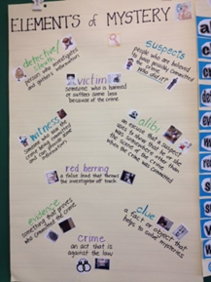  http://media-cache-ec0.pinimg.com/736x/8d/ca/d6/8dcad6a0e84667b28c727a8fba1718b8.jpg
I Do | Review: (1 min.)  We have explored the elements that writers use when writing a mystery and the specific vocabulary that good mystery writer’s use. We have also talked about the purpose that writers use for writing mysteries. Yesterday we read a story that is one in a series of mysteries. Today we will focus on the characters of a mystery.  Demonstrate/Model: (5-7 min.)  Review the character vocabulary that is specific to a mystery genre (detective, sleuth, suspect, victim, witness). Using The Missing Mitten Mystery by Steven Kellogg, the teacher models identifying each specific character from the story and write one sentence about each.
We Do | Guided Practice: (3-5 min.)  Using the handout The Case of the Ruined Roses the students complete the same activity with a partner, identifying each specific character from the story and discussing the importance of each role.
You Do | Students will: (20 – 30 min.)  Begin to consider good characters for their own personal mystery story. Complete the Mystery Characters Handout and then choose characters to include in your mystery completing the first box on the Mystery Graphic Organizer.
English Language Arts Georgia Standards of Excellence: | ELAGSE4W5 With guidance and support from peers and adults, develop and strengthen writing as needed by planning, revising, and editing. (Editing for conventions should demonstrate command of Language Standards 1–3 up to and including grade 4.)  ELAGSE4W3 Write narratives to develop real or imagined experiences or events using effective technique, descriptive details, and clear event sequences.

Day 10 | Collecting Ideas Teaching Point #2: I can create a setting to develop a mystery story.  Mentor Text(s): All previously used texts  Student Handout(s): List of possible settings, Mystery Graphic Organizer  Anchor Chart:  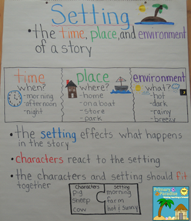  https://www.pinterest.com/explore/setting-anchor-charts/
I Do | Review: (1 min.)  We have explored the elements that writers use when writing a mystery and the specific vocabulary that good mystery writer’s use. Yesterday, we focused on the characters of a mystery. Today, we will focus on a mysterious setting.  Demonstrate/Model : (5-7 min.)  Discuss the setting of each of the mentor text that we have used for our mystery writing unit. Discuss the differences between the settings. Some are scary and others are funny. Any place and time can be used in a mystery. Model writing a paragraph using the classroom as our setting.
We Do | Guided Practice: (3-5 min.)  Using a list of possible settings cut apart. The students will take turns pulling a possible setting from a jar and describe the setting to a partner.
You Do | Students will: (20 – 30 min.)  Write a paragraph describing a possible setting for their personal mystery. Then complete the setting section of the Mystery Graphic Organizer
English Language Arts Georgia Standards of Excellence: | ELAGSE4W5 With guidance and support from peers and adults, develop and strengthen writing as needed by planning, revising, and editing. (Editing for conventions should demonstrate command of Language Standards 1–3 up to and including grade 4.)  ELAGSE4W3 Write narratives to develop real or imagined experiences or events using effective technique, descriptive details, and clear event sequences.

Day 11 | Collecting Ideas Teaching Point #3: I can write a possible clue to help solve a mystery story.  Mentor Text(s): Nate the Great and the Stolen Base  Student Handout(s): Mystery Graphic Organizer  Anchor Chart: Clues Anchor Chart Attached
I Do | Review: (1 min.)  We have explored the elements that writers use when writing a mystery and the specific vocabulary that good mystery writer’s use. We focused on the characters and setting of a mystery. Yesterday, we focused on the plot or crime in a mystery! Clues are essential to any good mystery. This is how the writer engages the reader. Today we will focus on how writers develop clues.  Demonstrate/Model: (5-7 min.)  Using Nate the Great and the Stolen Base, the teacher will list the clues from the mentor text. Who reveals the clues and how they were discovered. Discuss what makes a good clue.
We Do | Guided Practice: (3-5 min.)  Using one of the mentor texts, the students work with a partner to list the clues and discuss how the clues were discovered and who revealed the clue.
You Do | Students will: (20 – 30 min.)  Write a list of clues for your personal mystery. Then complete the clues section of the Mystery Graphic Organizer.
English Language Arts Georgia Standards of Excellence: | ELAGSE4W5 With guidance and support from peers and adults, develop and strengthen writing as needed by planning, revising, and editing. (Editing for conventions should demonstrate command of Language Standards 1–3 up to and including grade 4.)  ELAGSE4W3 Write narratives to develop real or imagined experiences or events using effective technique, descriptive details, and clear event sequences.

Day 12 | Collecting Ideas Teaching Point #4: I can write a red herring to distract my readers and make my mystery intriguing.  Mentor Text(s): All previous mentor text  Student Handout(s): Selecting Worksheet  Anchor Chart:  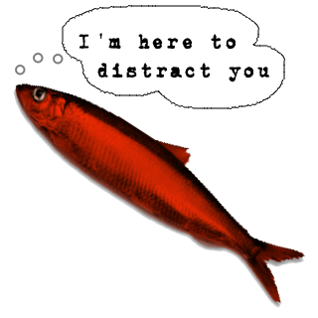  http://www.missbsresources.com/index.php/blog/18-teaching-and-learning/69-stretching-the-challenge
I Do | Review: (1 min.)  We have explored the elements that writers use when writing a mystery and the specific vocabulary that good mystery writer’s use. We focused on the characters and setting of a mystery. Yesterday, we focused on the plot or crime in a mystery! Clues are essential to any good mystery. This is how the writer engages the reader. Today we will consider adding a red herring to our story.  Demonstrate/Model: (5-7 min.)  Discuss the red herring clues that were used in the mentor texts to confuse the reader.
We Do | Guided Practice: (3-5 min.)  The students will work with a partner and discuss additional red herrings in the mentor text of their choice.
You Do | Students will: (20 – 30 min.)  The students will write a list of possible red herrings to use in their mystery, and then choose at least one to incorporate in the story.
English Language Arts Georgia Standards of Excellence: | ELAGSE4W5 With guidance and support from peers and adults, develop and strengthen writing as needed by planning, revising, and editing. (Editing for conventions should demonstrate command of Language Standards 1–3 up to and including grade 4.)  ELAGSE4W3 Write narratives to develop real or imagined experiences or events using effective technique, descriptive details, and clear event sequences.

Day 13 | Drafting Teaching Point #1: I can write my mystery ideas in a logical order.  Mentor Text(s):  Student Handout(s): Selecting Worksheet  Anchor Chart:  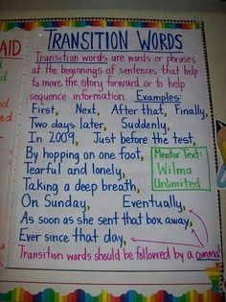  https://www.pinterest.com/linwentz/transition-words/
I Do | Review: (1 min.)  We have explored the elements that writers use when writing a mystery and the specific vocabulary that good mystery writer’s use. We focused on the characters and setting and the plot or crime in a mystery! We have collected ideas to use in our story by adding good clues and a red herring. Today we will focus on drafting our mystery and the importance of arranging your ideas in a logical order.  Demonstrate/Model: (5-7 min.)  On the board the teacher writes three events from a mentor text out of order. The teacher explains that when the story is out of order it makes no sense to the reader. The teacher rearranges the story events in the appropriate order.
We Do | Guided Practice: (3-5 min.)  With a partner, the student discusses the events that could occur in their mystery story. With the partner the students decide on an appropriate order for a minimum of five events.
You Do | Students will (20 – 30 min.)  Each student begins drafting their mystery paper keeping the events in the appropriate order.
English Language Arts Georgia Standards of Excellence: | ELAGSE4W3 Write narratives to develop real or imagined experiences or events using effective technique, descriptive details, and clear event sequences.

Day 14 | Drafting Teaching Point #2: I can write mystery details with descriptive details.  Mentor Text(s):  Student Handout(s): Selecting Worksheet  Anchor Chart:  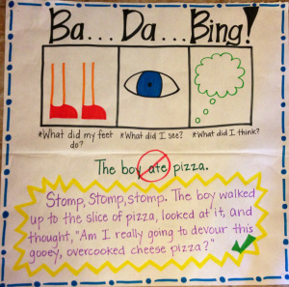  https://texasteachingfanatic.wordpress.com/anchor-charts/
I Do | Review: (1 min.)  We have explored the elements that writers use when writing a mystery and the specific vocabulary that good mystery writer’s use. We focused on the characters and setting and the plot or crime in a mystery! We have collected ideas to use in our story by adding good clues and a red herring. Today we will continue drafting our mystery and focus on adding details to make our story interesting.  Demonstrate/Model (5-7 min.)  The teacher reviews the anchor chart encouraging the students to add details to their writing.
We Do | Guided Practice: (3-5 min.)  With a partner the students will choose one simple sentence from the students writing that can be expanded. The students will verbalize suggested ways to expand the writing.
You Do | Students will (20 – 30 min.)  Each student continues drafting their mystery.
English Language Arts Georgia Standards of Excellence: | ELAGSE4W3 Write narratives to develop real or imagined experiences or events using effective technique, descriptive details, and clear event sequences.

Day 15 | Drafting Teaching Point #3: I can write mystery details with descriptive details.  Mentor Text(s):  Student Handout(s): Selecting Worksheet  Anchor Chart:  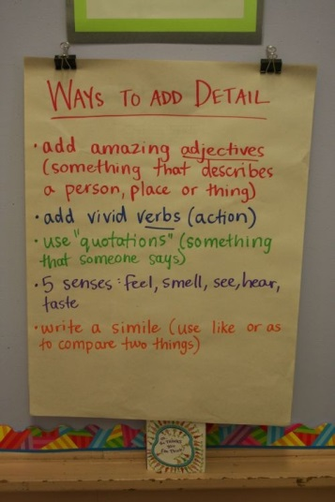  http://msvigna.com/curriculum/
I Do | Review: (1 min.)  We have explored the elements that writers use when writing a mystery and the specific vocabulary that good mystery writer’s use. We focused on the characters and setting and the plot or crime in a mystery! We have collected ideas to use in our story by adding good clues and a red herring. Today we will continue drafting our mystery and focus on adding details to make our story interesting.  Demonstrate/Model (5-7 min.)  The teacher reviews the anchor chart encouraging the students to add details to their writing.
We Do | Guided Practice: (3-5 min.)  With a partner the students will choose at least one of the suggestions from the anchor chart to incorporate into their writing. The students will verbalize suggested ways to expand the writing.
You Do | Students will (20 – 30 min.)  Each student continues drafting their mystery.
English Language Arts Georgia Standards of Excellence: | ELAGSE4W3 Write narratives to develop real or imagined experiences or events using effective technique, descriptive details, and clear event sequences.

Day 16 | Revising Teaching Point #1: I can write an introduction to hook my audience.  Mentor Text(s): All previous texts  Student Handout(s):  Anchor Chart:  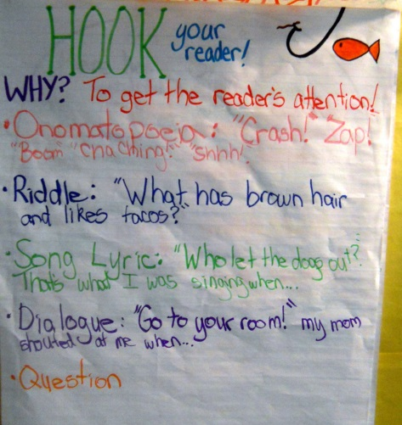  http://juiceboxesandcrayolas.blogspot.com/2011/11/anchors-away-linky-party-language-arts.html
I Do | Review: (1 min.)  Your story should be fairly well developed. Today we will focus on techniques that writers could use to make their introductions more interesting.  Demonstrate/Model (5-7 min.)  Review the introductions that the authors used in the mentor text.
We Do | Guided Practice: (3-5 min.)  With a partner the students will verbalize three possible hooks for their mystery.
You Do | Students will (20 – 30 min.)  Each student continues drafting their mystery writing a strong lead.
English Language Arts Georgia Standards of Excellence: | ELAGSE4W3 Write narratives to develop real or imagined experiences or events using effective technique, descriptive details, and clear event sequences.

Day 17 | Revising Teaching Point #2: I can write a conclusion to complete my mystery.  Mentor Text(s):  Student Handout(s):  Anchor Chart:  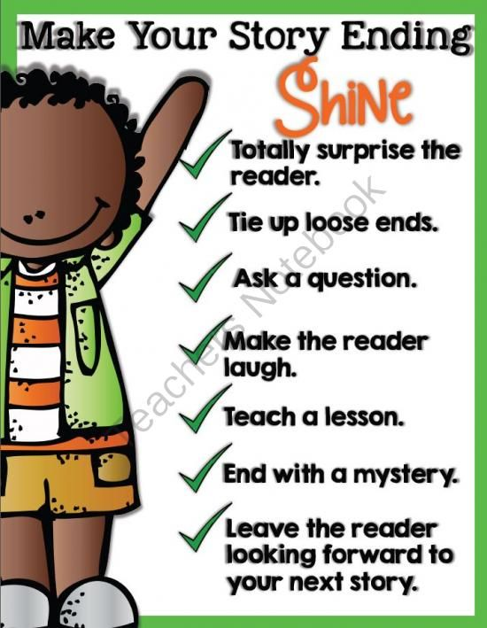  http://www.teachersnotebook.com/product/TeachingWithTLC/make-your-story-endings-shine
I Do | Review: (1 min.)  Your story should be fairly well developed. Yesterday we focused on techniques that good writers use to make their introductions more interesting. Today, we will focus on the ending of your story.  Demonstrate/Model (5-7 min.)  Review the endings that the authors used in the mentor text.
We Do | Guided Practice: (3-5 min.)  With a partner the students will verbalize three possible hooks for their mystery.
You Do | Students will (20 – 30 min.)  Each student continues drafting their mystery writing a strong ending.
English Language Arts Georgia Standards of Excellence: | ELAGSE4W3 Write narratives to develop real or imagined experiences or events using effective technique, descriptive details, and clear event sequences.

Day 18 | Revising Teaching Point #3: I can revise my mystery story to make it better.  Mentor Text(s):  Student Handout(s): Super Sleuth Peer Editing Sheet (Read, Write, Think)  Anchor Chart:  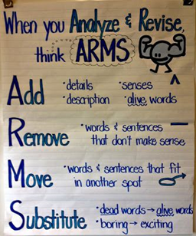
I Do | Review: (1 min.)  Today we will begin revising our mystery. We have a rough draft and have developed a story line. We have added a strong beginning and ending. Today we will work to make our story better.  Demonstrate/Model (5-7 min.)  Teacher will go over the steps in ARMS using the Anchor Chart provided.
We Do | Guided Practice: (3-5 min.)  Teacher will use a pre-written paragraph to allow students to help make improvements to make the paragraph more interesting.
You Do | Students will (20 – 30 min.)  Peer Revise
English Language Arts Georgia Standards of Excellence: | ELAGSE4W5 With guidance and support from peers and adults develop and strengthen writing as needed by planning, revising, and editing.

Day 19 | Revising Teaching Point #4: I can revise my mystery story to make it better.  Mentor Text(s):  Student Handout(s):  Anchor Chart:  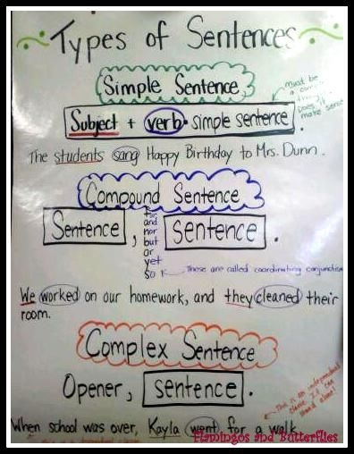  http://indulgy.com/post/HjiCuDiTD2/anchors-writing-types-of-sentences-jeff-anderso
I Do | Review: (1 min.)  Today we will continue revising our mystery. We have a rough draft and have developed a story line. We have added a strong beginning and ending. Today we will continue to make our story better, focusing on using a variety of different sentences.  Demonstrate/Model (5-7 min.)  Teacher will review the anchor chart with students displaying different types of sentences.
We Do | Guided Practice: (3-5 min.)  Students will look at their writings with a partner. They will discuss orally ideas to improve their sentence variety.
You Do | Students will (20 – 30 min.)  Students will revise their writing using a variety of sentence types.
English Language Arts Georgia Standards of Excellence: | ELAGSE4W5 With guidance and support from peers and adults develop and strengthen writing as needed by planning, revising, and editing.

Day 20 | Editing Teaching Point #1: I can edit my mystery story to make it correct.  Mentor Text(s):  Student Handout(s):  Anchor Chart:  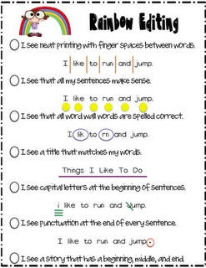  https://docs.google.com/folderview?id=0B43EXsq0Y2y_YzZiYTgyNDctMDk3OS00Mjc2LTg5OTgtNjliYTkxYjE0NjI4&usp=drive_web
I Do | Review: (1 min.)  Today we will begin editing our mystery. We have revised our writing to make it better. Today we will begin focusing on making it correct.  Demonstrate/Model (5-7 min.)  Teacher will refer to the Anchor Chart provided to introduce editing.
We Do | Guided Practice: (3-5 min.)  Students will be given sentences to edit with a partner. Teacher will review the corrections.
You Do | Students will (20 – 30 min.)  Students will begin editing their mystery.
English Language Arts Georgia Standards of Excellence: | ELAGSE4W5 With guidance and support from peers and adults develop and strengthen writing as needed by planning, revising, and editing.

Day 21 | Editing Teaching Point #2: I can edit my mystery story to make it correct.  Mentor Text(s):  Student Handout(s):  Anchor Chart:  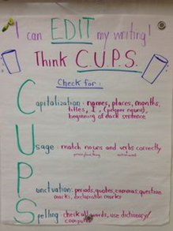
I Do | Review: (1 min.)  Today we will continue editing our mystery. We have revised our writing to make it better. Today we will continue to focus on making corrections.  Demonstrate/Model (5-7 min.)  Teacher will introduce CUPS to students using the Anchor Chart provided.
We Do | Guided Practice: (3-5 min.)  Students will be given sentences to edit with a partner. Teacher will review the corrections.
You Do | Students will (20 – 30 min.)  Students will continue editing their mystery.
English Language Arts Georgia Standards of Excellence:

Day 22 | Editing Teaching Point #3: I can edit my mystery story to make it correct.  Mentor Text(s):  Student Handout(s):  Anchor Chart:  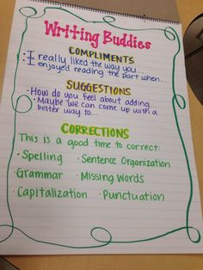  https://www.pinterest.com/mrsewiley/writing-process/
I Do | Review: (1 min.)  Today is our last day to edit our mystery before we begin publishing. Remember the methods we have learned over the past few days.  Demonstrate/Model (5-7 min.)  Teacher will review how to be Writing Buddies as they peer edit the papers.
You Do | Students will (30 – 35 min.)  Students will work with a partner to Peer Edit their papers.
English Language Arts Georgia Standards of Excellence: | ELAGSE4W5 With guidance and support from peers and adults develop and strengthen writing as needed by planning, revising, and editing.

Day 23 | Publishing Teaching Point #1: I can publish my mystery to make it appealing to my readers.  Mentor Text(s):  Student Handout(s):  Anchor Chart:  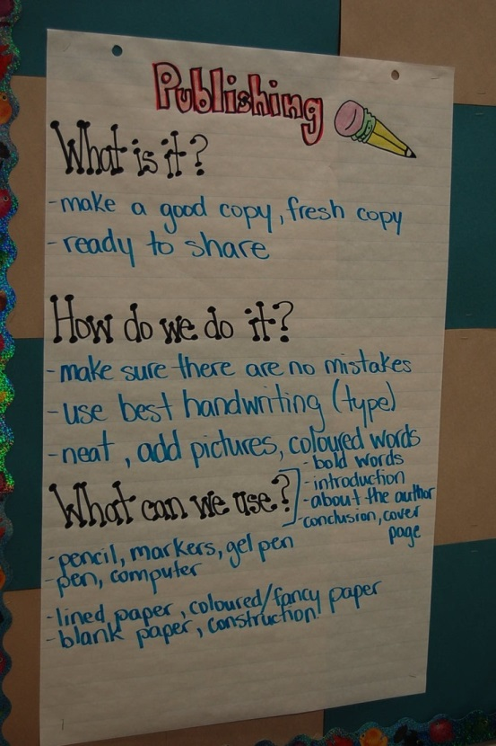  http://3.bp.blogspot.com/-OsS6KoUFzRU/TrM7fVgs2YI/AAAAAAAABSQ/2ORUrjVOx7U/s1600/DSC_0326.JPG
I Do | Review: (1 min.)  Today we will begin publishing our mysteries.  Demonstrate/Model (5-7 min.)  Teacher will review the anchor chart with students.
You Do | Students will (30 – 35 min.)  Students will begin working in the computer lab to publish their mystery.
English Language Arts Georgia Standards of Excellence: | ELAGSE4W6 With some guidance and support from adults, use technology, including the internet, to produce and publish writing as well as to interact and collaborate with others; demonstrate sufficient command of keyboarding skills to type a minimum of one page in a single setting.

Day 24 | Publishing Teaching Point #2: I can publish my mystery to make it appealing to my readers.  Mentor Text(s):  Student Handout(s):  Anchor Chart:  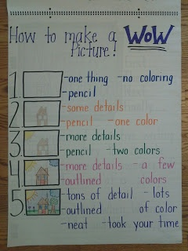  http://spottedinfirstgrade.blogspot.com/2013/07/writing-in-my-classroom.html
I Do | Review: (1 min.)  Today we will continue to publish our mysteries.  Demonstrate/Model (5-7 min.)  Teacher will review the anchor chart on using pictures to enhance their writing.
You Do | Students will (30 – 35 min.)  Students will finish working in the computer lab to publish their mystery. Students will begin adding illustrations.
English Language Arts Georgia Standards of Excellence: | ELAGSE4W6 With some guidance and support from adults, use technology, including the internet, to produce and publish writing as well as to interact and collaborate with others; demonstrate sufficient command of keyboarding skills to type a minimum of one page in a single setting.

Day 25 | Publishing Teaching Point #3: I can publish my mystery to make it appealing to my readers.  Mentor Text(s): All previous texts  Student Handout(s):  Anchor Chart:
I Do | Review: (1 min.)  Today is our last day publishing our mystery. You all have worked very hard to create an interesting story that will engage the reader. Today we will add our finishing touches.  Demonstrate/Model (5-7 min.)  Teacher will use a mentor text to show the students examples of a cover page, title page, about the author page, and a dedication page.
We Do | Guided Practice: (3-5 min.)  Students will look at a variety of picture books and find the examples listed above.
You Do | Students will (20 – 30 min.)  Student will add a cover page, title page, about the author page, and a dedication page.
English Language Arts Georgia Standards of Excellence: | ELAGSE4W6 With some guidance and support from adults, use technology, including the internet, to produce and publish writing as well as to interact and collaborate with others; demonstrate sufficient command of keyboarding skills to type a minimum of one page in a single setting.

Clues Anchor Chart
Clues are hints that help the detectives and reader solve the mystery.

Three Types of Clues
Physical clues range from fingerprints to DNA analysis. The detective can repeatedly examine the scene of the crime, sort through the personal items, and review the photographs. These are clues that someone can see, taste, or touch.

Verbal clues come from dialogue between characters. What is said and not said? Who knew what only the killer would know or left out some crucial detail? These are clues that are heard from people.

Thematic clues are those pointers that arise from the experience of reading. The person dressed in black is the villain. The stormy night signals danger. A loud bang could be a gun shot. These are clues that you know from past experiences or other stories that you have heard, seen, or read.

