5th Grade Narrative Unit: Memoir
Immersion Teaching Point # 1  Learning Target: I can explain the elements of a memoir.  - Inform/ Review (1-2 min): Today we will begin a new type of writing—one that you may not know about. We are going to learn what a memoir is and examples of what a memoir looks like.  - Present/Model (5-7 min):  Teacher reads When I Was Young in the Mountains by: Cynthia Rylant  After you have read the text, display the anchor chart that contains the elements of a memoir.  Refer back to the text, and do a quick check of the elements. Does this story contain all or most of the elements?  - Guided Practice (3-5 min)  Read or display an excerpt from Marshfield Dreams author: Ralph Fletcher  Write the title of the text on the elements anchor chart titled “Memoir Mentors”  Complete the checklist as a class—ask students if the elements are included in the text and ensure that students can pinpoint examples from the text.  Mentor Texts(s):  When I Was Young in the Mountains by: Cynthia Rylant  Marshfield Dreams by: Ralph Fletcher  Anchor Chart(S):  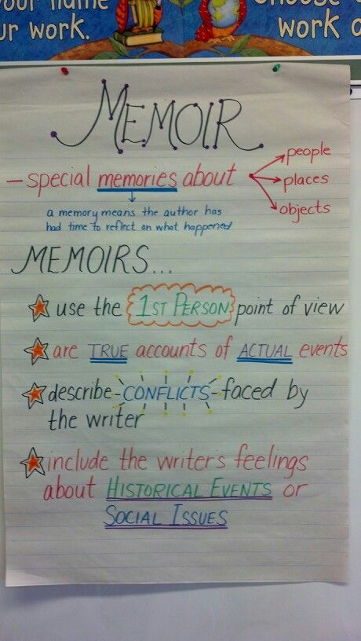 | - Independent Practice  Students will read addition excerpts from Marshfield Dreams and complete their own checklist of memoir elements.  **This checklist should be glued into interactive notebook or put into the writing folder  Student Handout(s):  Memoir checklist (resources for memoir)  Standards:  ELAGSE5W3: Write narratives to develop real or imagined experiences or events using effective technique, descriptive details, and clear event sequences.

Immersion Teaching Point # 2  Learning Target: I can explain the importance of emotional connections when writing a memoir.  - Inform/ Review (1-2 min): So, yesterday we learned the elements of a memoir and read some examples.  Today, we are going to read another memoir and look at how the author writes so that the reader feels like he/she is a part of the memory.  - Present/Model (5-7 min):  Authors are inspired by emotional memories.  Read Fireflies by: Julie Brinckloe and draw attention to the craft used to create/evoke emotion.  Explain that there isn’t very much information on Julie Brinckloe or her background.  The teacher will read the author’s note.  - Guided Practice (3-5 min):  Turn and Talk: What do you think inspired Julie Brinckloe write Fireflies?  What emotion was created through the writing of this piece?  What is important about this memory?  Display the Memory Chart. As a class, determine the inspiration, emotion, and the importance of this event. (The importance will likely be inferred).  Mentor Text(s):  Fireflies by: Julie Brinckloe  Anchor Chart(s): | - Independent Practice  The students will be given copies of excerpts from Knucklehead by: Jon Scieszka. They will read these and complete the chart.  Memory OR inspiration /emotion/importance.  After reading the text, each pair/ group of students will determine the event described and the importance of this event.  Student Handout(s):  Memory chart (resources for memoir)  Standards:  ELAGSE5W3: Write narratives to develop real or imagined experiences or events using effective technique, descriptive details, and clear event sequences.

Immersion Teaching Point # 3  Learning Target: I can explain how authors use craft to take ordinary memories and make them extraordinary  - Inform/ Review (1-2 min): Yesterday, we learned the elements of a memoir. Today, we will learn that authors take ordinary memories and turn them into extraordinary pieces of writing.  - Present/Model (5-7 min): Authors use different craft to  make their writing appealing to readers. They  may use descriptive language, special font, figurative  language, etc.  Teacher will read Saturdays and Teacakes by: Lester Laminack and draw attention to the ordinary memory (cooking with his grandmother on Saturdays). Explain to students that the way in which this memory is described makes it extraordinary.  Notice—the author includes every moment with such great description.  - Guided Practice (3-5 min): Using the anchor chart “Taking Ordinary to Extraordinary.”  Fill in ordinary events from Saturdays and Teacakes: riding the bike, baking, mowing, sitting on the porch etc.  As a class, jot down examples of how Lester Laminack turns these ordinary moments into extraordinary through author’s craft.  Example: Riding a bike is ordinary. How does the author make this extraordinary?  Mentor Texts(s):  Saturdays and Teacakes by: Lester Laminack  Knucklehead by: Jon Scieszka  Marshfield Dreams by: Ralph Fletcher  House on Mango Street by: Sandra Cisneros  Anchor Chart(S):  Display “Ordinary to Extraordinary.” You may want to refer back to this during drafting and revision to encourage students to use specific crafts in writing. | - Independent Practice: Students will read excerpts from the mentor texts and continue to complete the chart.  What are the ordinary memories? What details does the author include to make these memories extraordinary?  Student handout(s): “Ordinary to Extraordinary”  Standard:  ELAGSEW3  b. Use narrative techniques, such as dialogue, description, and pacing, to develop experiences and events or show the responses of characters to situations.

Immersion Teaching Point # 4  Learning Target: I can consider how the point of view affects the reader’s experience.  - Inform/ Review (1-2 min):  Yesterday, we learned that authors turn ordinary memories to extraordinary moments through craft. Today, we will learn how the use of different points of view and perspectives can affect the reader’s experience.  - Present/Model (5-7 min):  When authors write, they take many things into consideration. One of those is point of view. Adopting a dog can be an exciting time for a little boy or girl, but what about the dog’s experience?  The teacher will read Trouper by: Meg Kearney and draw attention to the fact that this memoir is told from the point of view of the dog. Be sure to include that we know his thoughts and feelings and not the thoughts and feelings of the other characters in the text. Notice how Trouper reflects on his beginnings as a puppy, problems with the world (boys throwing rocks), and activities and compares them to his present situation.  - Guided Practice (3-5 min)  Create a web of other possible points of view from Trouper.  Some suggestions include: other dogs, the boys in the street, man from Animal Control, woman from the pound, boy who adopted.  Turn and talk about one of the characters—What might they have said, felt, thought?  Mentor Texts(s):  Trouper by: Meg Kearney  Anchor Chart(S): | - Independent Practice  In their writer’s notebook, students will choose one character and scene from the text (Trouper) to write from a different point of view.  Include: thoughts, speech, feelings, and action.  Student Handout(s):  You could provide web or bubble map for students who need one.  Standards:  ELAGSE5W3: Write narratives to develop real or imagined experiences or events using effective technique, descriptive details, and clear event sequences.

Immersion Teaching Point # 5  Learning Target: I can explain the difference between a memoir and a personal narrative.  - Inform/ Review (1-2 min):  Yesterday we discussed the importance of considering point of view when writing a memoir. Today, we are going to learn the difference between memoirs and personal narratives.  - Present/Model (5-7 min):  Let’s watch as Dr. Linda Bausch explains the difference between a memoir and a personal narrative.  http://www.watchknowlearn.org/Video.aspx?VideoID=30444&CategoryID=3370  Teacher will read Bigmama’s by: Donald Crews and point out the reflective ending. Refer back to the other texts that have been read, and just touch on those that have reflective endings.  - Guided Practice (3-5 min)  Turn and talk: What are the differences between a memoir and personal narrative?  Answers: A memoir has both a reflective ending and some time has gone by. The time element is important for the author’s or character’s reflection.  In the book Fireflies, we can assume that time has passed and this is a retelling of a distant memory. However, it is lacking a reflective ending.  Mentor Texts(s):  Bigmama’s by: Donald Crews  Fireflies by: Julie Brinckloe  Anchor Chart(S):  It is recommended that you create an anchor chart of the main differences between a memoir and personal narrative. When students are writing their memoir, they need to remember that it needs to include a reflective ending, and that time must have passed between the memory and the present. It shouldn’t be something that happened last week or even a few months ago. | - Independent Practice  The students will be given a printed copy of Fireflies. They will be responsible for creating a reflective ending. Be sure to encourage them to refer back to Bigmama’s.  Student Handout(s):  “Memoir Vs. Personal Narrative” (resources for memoir)  Standards:  ELAGSE5W3  e. Provide a conclusion that follows from the narrated experiences or events.

Generating Ideas Teaching Point # 1  Learning Target: I can generate ideas based on important people in my life.  - Inform/ Review (1-2 min):  During immersion, we learned that authors draw from personal experiences and memories to create their memoirs. Today, we will begin generating ideas for our memoirs based on important people in our lives.  - Present/Model (5-7 min):  When I read the text, think about the important people in the characters’ lives, and the way in which they are described.  Reread excerpts from Saturdays and Teacakes, Bigmama’s, and any excerpt from Marshfield Dreams. Discuss the important people in these texts.  On an anchor chart, model your own generating process for important people.  Categories—Family, friends, teachers, other  - Guided Practice (3-5 min)  Turn and talk- who is an important person in your life with whom you have a special memory? What is that memory?  Mentor Texts(s):  Saturdays and Teacakes by: Lester Laminack  Big Mamas by: Donald Crews  Marshfield Dreams by: Ralph Fletcher  Anchor Chart(S):  It is recommended that you create an anchor chart of generic or student generated ideas—this is helpful for those who are struggling to think of topics on their own.  (Continue adding to the same anchor chart) | - Independent Practice  Students will use an organizer OR list in notebook OR create a heart map to generate ideas about important people in their lives and the memory associated with that person.  When students have completed generating in the organizer, they will complete an entry. The entry needs to be about half a page. If students finish one entry, they can choose another memory and complete another entry.  Student Handout(s):  In the writers notebook:  Subject Memory  Person  Event/Moment  Objects  Standards:  ELAGSE5W3: Write narratives to develop real or imagined experiences or events using effective technique, descriptive details, and clear event sequences.

Generating Ideas Teaching Point # 2  Learning Target: I can generate ideas based on memorable events/ emotional moments in my life.  - Inform/ Review (1-2 min):  Yesterday, we generated ideas by thinking about important people in our lives. Today we will generate ideas based on memorable or emotional moments in our lives.  - Present/Model (5-7 min):  During immersion, we learned that authors can create memoirs from really special moments in their lives. Often, the writers remember these moments because they created a strong feeling or emotion.  Let’s look back at some of our mentor texts and  think about what made these events  memorable.  Reread excerpts from Trouper, Fireflies, and  Knucklehead. Draw attention to the emotion  surrounding these memories.  The teacher will model generating ideas about  memorable moments in His/her own life.  (Preferably from childhood)  - Guided Practice (3-5 min)  Turn and talk: What are two important event or moment in your life that created a strong emotion? Why did you have such a strong emotion?  Mentor Texts(s):  Trouper by: Meg Kearney  Fireflies by: Julie Brinkloe  Knucklehead by: Jon Scieszka  Anchor Chart(S):  It is recommended that you create an anchor chart of generic or student generated ideas—this is helpful for those who are struggling to think of topics on their own.  (Continue adding to the same anchor chart) | - Independent Practice  Students will use an organizer OR list in notebook OR create a heart map to generate ideas about important people in their lives and the memory associated with that person.  When students have completed generating in the organizer, they will complete an entry. The entry needs to be about half a page. If students finish one entry, they can choose another memory and complete another entry.  Student Handout(s):  In the writers notebook:  Subject Memory  Person  Event/Moment  Objects  Standards:  ELAGSE5W3: Write narratives to develop real or imagined experiences or events using effective technique, descriptive details, and clear event sequences.

Generating Ideas Teaching Point # 3  Learning Target: I can generate ideas based on special physical objects.  - Inform/ Review (1-2 min):  Yesterday, we generated ideas based on emotional moments in our lives. Today we will generate ideas about objects that mean something special to us.  - Present/Model (5-7 min):  Pull excerpts from Marshfield Dreams or Knucklehead that focus on an important object.  OR  Read The Rag Coat, The Keeping Quilt, or another memoir that focuses on a special object.  Point out the object and what the author writes that makes this object to special.  - Guided Practice (3-5 min)  Turn and talk: What is/are special object(s) that are important to you? Why? What is the memory you have?  Mentor Texts(s):  The Rag Coat by: Lauren Mills  The Keeping Quilt by: Patricia Polacco  Marshfield Dreams by: Ralph Fletcher  Knucklehead by: Jon Scieszka  Anchor Chart(S): | - Independent Practice  Students will use an organizer OR list in notebook OR create a heart map to generate ideas about important people in their lives and the memory associated with that person.  When students have completed generating in the organizer, they will complete an entry. The entry needs to be about half a page. If students finish one entry, they can choose another memory and complete another entry.  Student Handout(s):  In the writers notebook:  Subject Memory  Person  Event/Moment  Objects  Standards:  ELAGSE5W3: Write narratives to develop real or imagined experiences or events using effective technique, descriptive details, and clear event sequences.

Selecting Teaching Point # 1  Learning Target: I can select the best topic for my memoir.  - Inform/ Review (1-2 min):  Over the past few days, we have generated ideas and written entries for our memoirs. Today, I am going to show you a great way to select a topic for your memoir.  - Present/Model (5-7 min):  Display the Memoir Selection Chart on the board. Model using your own entries to select four of your favorite. Write these into the first column, then complete the remainder of the chart.  - Guided Practice (3-5 min)  Now writers, look through your own writing notebook to determine which four topics you like best. Then turn and talk to someone around you about why these are your favorite.  Mentor Texts(s):  Anchor Chart(S): | - Independent Practice  Give students the memoir selection chart. They will complete the chart (except the last column.)  Once all students have completed the chart, explain that they will now get opinions from their classmates.  You will go around to your peers and give them a snapshot of each topic. They will then put their initials in the ONE topic they would like to read.  When students have had enough time to get ample signatures, have them come back to their seats and reflect on which topic is best for them.  Student Handout(s):  Selecting chart  Standards:  ELAGSE5W4: Produce clear and coherent writing in which the development and organization are appropriate to task, purpose, and audience.

**After this day, you will want to “go public.” This is just a chart that list all of your students’ names and their topics. See suggestions in the Unit Resources.

Collecting Teaching Point # 1  Learning Target: I can show, not tell emotion or feelings by using descriptive language.  - Inform/ Review (1-2 min):  We learned in immersion that authors create emotion through the use of description.  Today, we are going to practice showing, not telling readers.  - Present/Model (5-7 min):  Using his/her own topic, the teacher will begin brainstorming emotions that may be described in his/her memoir. *Could be a bubble map  Take one of those feelings and use description to show not tell.  Ex: I feel sick  - My face turned green  - My forehead was burning up  - Shivering  - Holding my stomach  - Guided Practice (3-5 min)  As a class, choose another emotion that is on the brainstorming sheet. Turn and talk: what are ways to show not tell this feeling.  Mentor Texts(s):  **Students may pull any of the texts from the unit as a guide and/or to assist with developing craft in their own memoirs.  Anchor Chart(S):  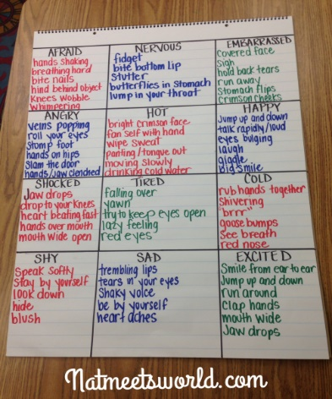 | - Independent Practice  Students will begin brainstorming feelings/emotions in their writing notebook. (Regarding their own memoir)  After brainstorming, they will write a few sentences showing not telling the emotion.  If one is finished, students move to another and another until work time ends.  Student Handout(s):  Standards:  ELAGSE5W3:  d. Use concrete words and phrases and sensory details to convey experiences and events precisely.

Collecting Teaching Point # 2  Learning Target: I can use sensory details to enhance my writing.  - Inform/ Review (1-2 min):  Good writers/authors use the five sense to help make writing more interesting. Today we will use this strategy to enhance our own memoirs.  - Present/Model (5-7 min):  Review excerpts from the mentor texts using during immersion. Highlight sensory details used by these authors.  **Suggestion: create a PowerPoint or flipchart with  these quotes from the text and the sensory detail  used by the author.  Thinking about his/her own topic selection, the  teacher will complete a couple columns from the  sensory detail chart.  - Guided Practice (3-5 min)  Turn and talk: what are some senses that would be included in your memoir? Describe them.  Mentor Texts(s):  **Students may pull any of the texts from the unit as a guide and/or to assist with developing craft in their own memoirs.  Anchor Chart(S): | - Independent Practice  Give each student a “sensory details” chart. They will brainstorm some of the senses and/or sensory details that could be included in their memoir. Have them jot down some phrases to go with each.  Student Handout(s):  Sensory Details (unit resources)  Standards:  ELAGSE5W3: Write narratives to develop real or imagined experiences or events using effective technique, descriptive details, and clear event sequences.  d. Use concrete words and phrases and sensory details to convey experiences and events precisely.

Collecting Teaching Point # 3  Learning Target: I can consider other points of view when writing a memoir.  - Inform/ Review (1-2 min):  Yesterday, we worked on collecting sensory details for our memoirs. Today, we will think about all of the points of view that may be included in our writing pieces.  - Present/Model (5-7 min):  Remember when we read Trouper? This text was told from an unlikely point of view, but other points of view could have been considered when Meg Kearney wrote this story.  Using his/her own memoir topic, make a list of all points of that could be considered.  Focusing on one of these points of view, write a short entry from that POV.  - Guided Practice (3-5 min)  Turn and talk: What is your topic? What are other points of view that may need to be considered?  Mentor Texts(s):  Trouper by: Meg Kearney  **Students may pull any of the texts from the unit as a guide and/or to assist with developing craft in their own memoirs.  Anchor Chart(S): | - Independent Practice  In their writing notebooks, students will brainstorm other points of view regarding their own memoir. Then they will begin writing short entries from these points of view.  **What did they feel, think, see, say?  Student Handout(s):  Standards:  ELAGSE5W3: Write narratives to develop real or imagined experiences or events using effective technique, descriptive details, and clear event sequences.

Collecting Teaching Point # 4  Learning Target: I can organize my memoir into a sequence that unfolds naturally.  - Inform/ Review (1-2 min):  We have spent the last few days gathering and collecting additional information for our memoirs. Today we will begin to organize the sequence of our own memoirs.  - Present/Model (5-7 min):  **You may choose to show an example of a timeline from one of the mentor texts first. For example, Trouper would be broken down as such:  - Running with other dogs  - Experience with neighborhood boys  - Going to the pound (that experience)  - Owner coming in (meeting the boy)  Review the information you have collected and considered for your own personal narrative.  The teacher will display a “timeline” for memoir. He/she will sequence the 4 or 5 main events of the memoir noting that the first box isn’t going to be the introduction, but the first major event. The last box won’t be the conclusion, but the last major event.  .  - Guided Practice (3-5 min)  Turn and talk. What is the first major event of your memoir? (make sure students are on the right track)  What is the last major event?  Mentor Texts(s):  Trouper  Anchor Chart(S): | - Independent Practice  Students will either be given a timeline to glue in or draw a timeline in the writing notebook.  Each student will record the 4/5 major events that will take place in the memoir.  Student Handout(s):  Timeline (unit resources)  Standards:  ELAGSE5W5: With guidance and support from peers and adults, develop and strengthen writing as needed by planning, revising, and editing.

Drafting Teaching Point # 1  Learning Target: I can develop the events of my memoir by adding details.  - Inform/ Review (1-2 min):  Yesterday we created a timeline of events for our memoir. This created a sequence of events to guide our writing.  Today we will begin the actual writing of our memoir.  - Present/Model (5-7 min):  Using the timeline, the teacher will model beginning the drafting process. Each point on the timeline will be on its own page. First, write the 4 or 5 points on their own page, the model writing the first page.  - Guided Practice (3-5 min)  Turn and talk about the first point on your timeline. Describe this event, in detail, to your neighbor.  Mentor Texts(s):  **Students may pull any of the texts from the unit as a guide and/or to assist with developing craft in their own memoirs.  Anchor Chart(S): | - Independent Practice  Students will get enough sheets of paper for each of their timeline points. (if possible, colored lined paper is good to use).  They will record each of the timeline points on sheets of paper. Then they will begin drafting page one. Remind students to include the information that was added during the collecting stage.  **Students need to skip lines when writing the draft.  Student Handout(s):  Standards:  ELAGSE5W5: With guidance and support from peers and adults, develop and strengthen writing as needed by planning, revising, and editing.

Drafting Teaching Point # 2 (May need 2 days)  Learning Target:  - Inform/ Review (1-2 min):  Yesterday, we used our timeline sequence to begin the drafting process. Today we will continue to draft the remainder of our memoir.  - Present/Model (5-7 min):  The teacher will model drafting another page. Be sure to think aloud about the information from collecting—include the sensory details, show don’t tell, etc.  - Guided Practice (3-5 min)  Turn and talk about the next point on your timeline (that you haven’t written. Describe this event, in detail, to your neighbor.  Mentor Texts(s):  **Students are encouraged to refer to any of the mentor texts throughout the writing unit.  Anchor Chart(S): | - Independent Practice  Students will continue writing the remainder of their drafts.  If students finish early, they can do one of the “I’m Done, Now What?” activities.  Student Handout(s):  “I’m Done, Now What?”  Standards:  ELAGSE5W5: With guidance and support from peers and adults, develop and strengthen writing as needed by planning, revising, and editing.

Revision Teaching Point # 1  Learning Target: I can write a strong lead that hooks my reader.  - Inform/ Review (1-2 min):  Now that we have drafted our narrative, we will do what real authors do and go back to our pieces several times to make it the best it can be.  - Present/Model (5-7 min):  There are many different types of leads.  Using the PowerPoint and hardcopies of texts, read the beginnings of the text and explain the lead that was used.  Trouper- Flashback lead  Saturdays and Teacakes-Flashback lead  Fireflies- Snapshot lead  Marshfield Dreams- Talking Lead  Do a think aloud to model the selection of your own type of lead. Then model writing a lead for your memoir.  - Guided Practice (3-5 min)  Turn and talk—which lead do you think would be best for your memoir? Why? Give a description.  Mentor Texts(s):  Trouper  Saturdays and Teacakes  Fireflies  Marshfield Dreams  Anchor Chart(S): | - Independent Practice  On a new sheet of paper, students will write a lead for their memoirs.  If students finish early, they need to try writing a different type of lead.  Students can refer to the handout for support.  Student Handout(s):  http://blogs.scholastic.com/files/leads-in-narrative-writing.doc.pdf  Standards:  ELAGSE5W3  a. Orient the reader by establishing a situation and introducing a narrator and/or characters; organize an event sequence that unfolds naturally.

Revision Teaching Point # 2  Learning Target: I can craft sentences that use prepositions to create fluency and variety.  - Inform/ Review (1-2 min):  Good writers/ authors make sure to use a variety of sentences that flow.  Today we are going to use prepositions to help with the flow of our sentences.  - Present/Model (5-7 min):  Using the mentor texts from immersion, pull excerpts that contain prepositions and/or prepositional phrases.  Suggestion: Make a powerpoint and/or flipchart with these quotes from the text.  Model using your own draft: read through and find places where your sentences are the same length or begin the same way. Refer to the prepositional phrases handout to help you rewrite some of these sentences.  - Guided Practice (3-5 min)  Display a sample paragraph. Working together, have students determine where there is a need for sentence variety or fluidity. Have them give suggestions of prepositions and/or phrases that would make it better.  Mentor Texts(s):  **Students may pull any of the texts from the unit as a guide and/or to assist with developing craft in their own memoirs.  Anchor Chart(S): | - Independent Practice  Students will work on rereading their drafts. They need to locate places where their sentences begin the same, are the same length, or need length in general.  In the skipped space or on the back, have students add prepositions or phrases to add fluency and variety to their memoirs.  Student Handout(s):  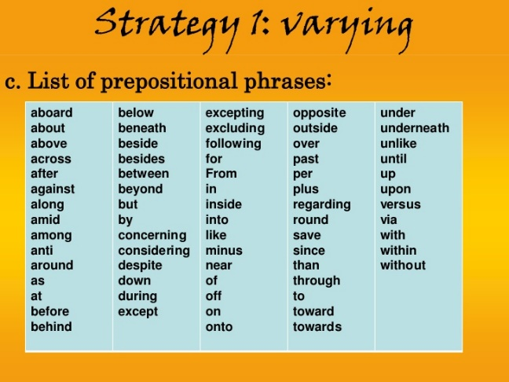  Standards:  ELAGGSE5L1: Demonstrate command of the conventions of Standard English grammar and usage when writing or speaking.  a. Explain the function of conjunctions, prepositions, and interjections in general and their function in particular sentences.

Revision Teaching Point # 3  Learning Target: I can add purposeful dialogue.  - Inform/ Review (1-2 min):  Yesterday we revised our drafts so that our sentences were different and flowed nicely. Today we will add meaningful dialogue to make our memoirs more interesting.  - Present/Model (5-7 min):  Good writers add dialogue to their writing, but they are very selective. They don’t just have full conversations in their stories.  Pull examples from mentor texts. Suggestions:  Marshfield Dreams, Fireflies, or Trouper.  Teacher will refer to his/her own draft and find one or two places where the dialogue should be added or modified.  - Guided Practice (3-5 min)  Turn and talk: What is something that someone said or could say to make your memoir more meaningful?  Mentor Texts(s):  Marshfield Dreams  Fireflies  Trouper  Anchor Chart(S):  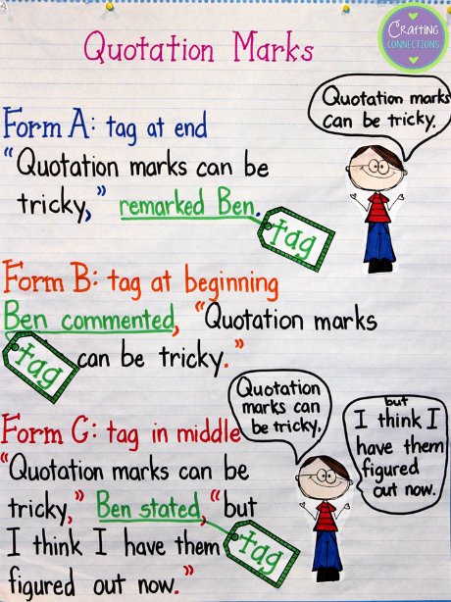 | - Independent Practice  Students will reread their drafts to find places to add or modify dialogue. When conferencing, be sure to reiterate the importance of limiting the amount of dialogue.  Student Handout(s):  Dialogue Rules—similar to anchor chart  Standards:  ELAGSE5W3: Write narratives to develop real or imagined experiences or events using effective technique, descriptive details, and clear event sequences.  b. Use narrative techniques, such as dialogue, description, and pacing, to develop experiences and events or show the responses of characters to situations.

Revision Teaching Point # 4  Learning Target: I can use transition words and phrases to help my memoir flow and manage the sequence of events.  - Inform/ Review (1-2 min):  We have already added fluency to our sentences by using prepositions and prepositional phrases. Today we are going to make sure that our entire memoir flows smoothly by using transition words and phrases.  - Present/Model (5-7 min):  Using any of the mentor texts from this unit, show examples and excerpts where the author(s) used transition words, phrases, and/or clauses.  Teacher will refer to his/her own memoir and model finding places to add or modify transitions. It is recommended that he/she use a variety of transitions.  - Guided Practice (3-5 min)  Display or give students a text to read and add transitions. You could even pull an excerpt from the mentor texts that had a transition, delete the transition, and have students add or modify.  Mentor Texts(s):  The Rag Coat by: Lauren Mills  The Keeping Quilt by: Patricia Polacco  Marshfield Dreams by: Ralph Fletcher  Knucklehead by: Jon Scieszka  Saturdays and Teacakes by: Lester Laminack  Big Mamas by: Donald Crews  Anchor Chart(S): | - Independent Practice  Students are responsible for reading/ rereading their drafts and adding or modifying transitions in the memoir. When conferencing, be sure that students are using a variety of transitions. Also, students should be connecting ideas through transitions, not just paragraphs.  Student Handout(s):  https://www.teacherspayteachers.com/Product/Common-Core-Writing-Transitional-Words-Anchor-Charts-399135  Standards:  ELAGSE5W3: Write narratives to develop real or imagined experiences or events using effective technique, descriptive details, and clear event sequences.  c. Use a variety of transitional words, phrases, and clauses to manage the sequence of events.

Revision Teaching Point # 5  Learning Target: I can create a reflective ending of the events and/or experience in my memoir.  - Inform/ Review (1-2 min):  Remember when we discussed the difference between a memoir and a personal narrative? We learned that a memoir has a reflective ending. This is due to the fact that the author/ character has had time to think about the memory/ event.  Today we will write our own ending in which we reflect on the events in our memoir.  - Present/Model (5-7 min):  Reread the reflective endings from mentor texts.  Bigmama’s, Trouper, and When I Was Young in the Mountains are all good examples.  It would be beneficial to have these ready in a powerpoint or flipchart.  The teacher will then refer to his/her own memoir, and develop a reflective ending as a model.  - Guided Practice (3-5 min)  Using the anchor chart, have students turn and talk: what are some of the elements you will include in your reflective ending/ conclusion?  Mentor Texts(s):  Bigmama’s  Trouper  When I Was Young in the Mountains  Anchor Chart(S):  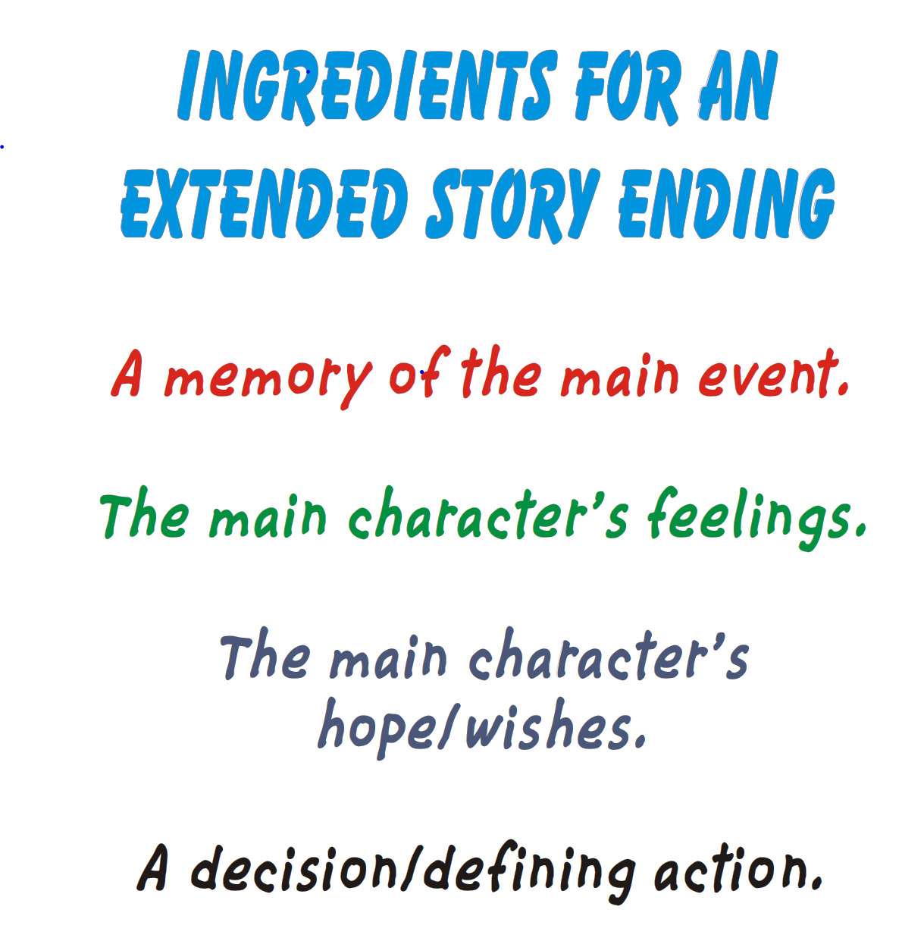 | - Independent Practice  Students are responsible for writing a reflective ending for their memoir. During conferencing, be sure that students have included all of the “ingredients” from the anchor chart.  Student Handout(s):  Optional: Provide a graphic organizer of the elements of a reflective ending.  Standards:  ELAGSE5W3: Write narratives to develop real or imagined experiences or events using effective technique, descriptive details, and clear event sequences.  e. Provide a conclusion that follows from the narrated experiences or events.

Editing Teaching Point # 1  Learning Target: I can use commas correctly in compound and complex sentences.  **The teaching of compound and complex sentences (with the use of conjunctions) should have already taken place before this mini-lesson.  - Inform/ Review (1-2 min):  Yesterday, we finished revising our memoirs. Today we will move to the editing stage. We will focus on using commas correctly to extend our sentences.  - Present/Model (5-7 min):  Refer to the anchor chart “Revising vs. Editing. Remember, we focus on CUPS.  We know that writers use compound and complex sentences to expand and combine sentences.** give an example of each.  I am going to look through my own memoir to find places where I might have made a mistake and need a comma, or I need to expand or combine sentences with a comma and conjunction.  - Guided Practice (3-5 min)  Display or give students a few sentences to correct. They will either use a comma and conjunction to combine sentences, or they will take sentence parts and combine them using a subordinating conjunction and comma. **could use personal whiteboards here  Check for understanding.  Mentor Texts(s):  **Students may pull any of the texts from the unit as a guide and/or to assist with developing craft in their own memoirs.  Anchor Chart(S):  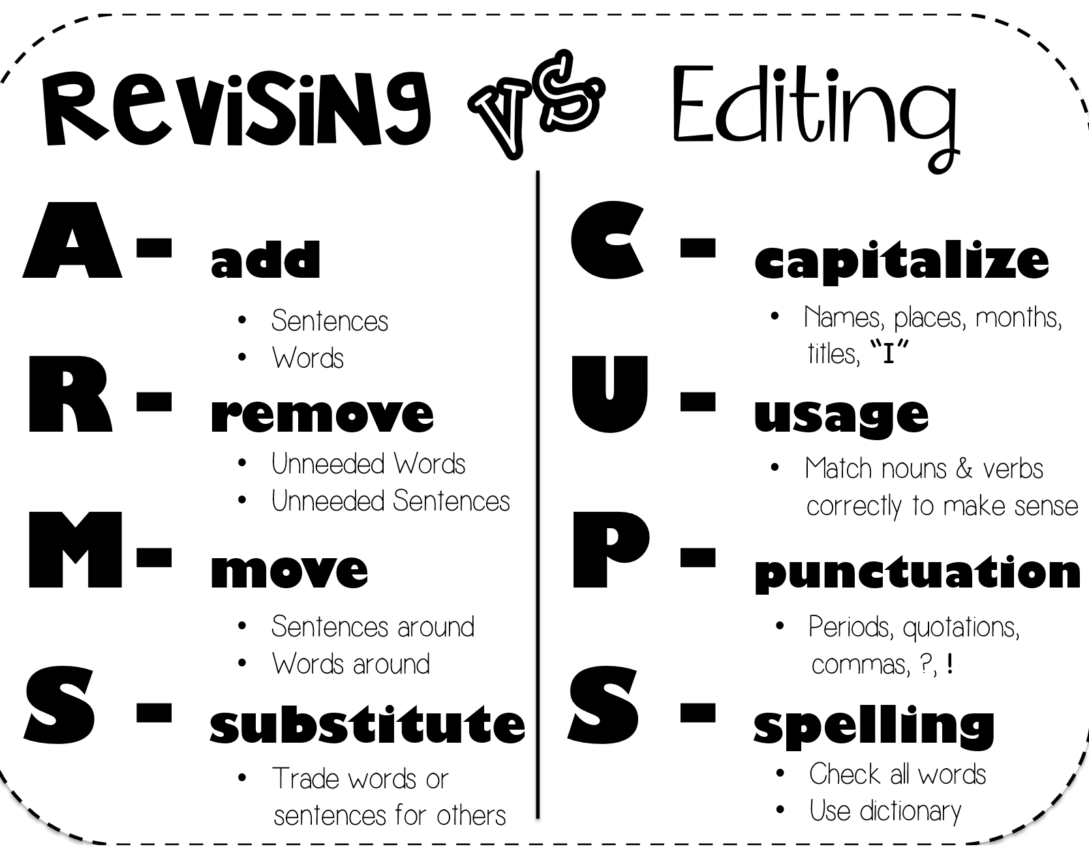 | - Independent Practice  Students will look for places in their own memoir where the need to add a comma(s), expand, or combine sentences using commas and conjunctions.  During conferences, you can circle or highlight suggestions.  Student Handout(s):  Standards:  ELAGSE5W3: Write narratives to develop real or imagined experiences or events using effective technique, descriptive details, and clear event sequences.

Editing Teaching Point # 2  Learning Target: I can use special types of font to highlight important portions of the text.  - Inform/ Review (1-2 min):  Good writers use visual effects to draw their readers in and make their texts more interesting. Today we are going to think about special fonts we could use to make our memoirs more interesting.  - Present/Model (5-7 min):  Refer back to any of the mentor texts from this unit. Highlight the use of special font in these texts, and their purpose.  The teacher will review his/her own memoir and find places where special types of font could be used. Make the changes and explain the effect of these you hope to have on the reader.  - Guided Practice (3-5 min)  Turn and talk: what types of font do you think you should add to your pieces?  **It would be beneficial to have some examples displayed for reference.  Mentor Texts(s):  Anchor Chart(S): | - Independent Practice  Students will locate place in the text where they would like to add special fonts. During conference, have students explain the effect of this font on the reader. Why are they choosing this? It needs to be deliberate and purposeful.  Student Handout(s):  Standards:  ELAGSE5W3: Write narratives to develop real or imagined experiences or events using effective technique, descriptive details, and clear event sequences.

Editing Teaching Point # 3  Learning Target: I can demonstrate proper conventions of spelling, capitalization, and punctuation.  - Inform/ Review (1-2 min):  Today we will focus on the small but effective changes in our writing. We will really think about capitalization, punctuation, and spelling.  - Present/Model (5-7 min):  We will be using an editing checklist to keep us focused on what to look for in our pieces. Of course, if you see something else that needs to be changes, go for it!  Model going through the checklist to make changes to your own memoir.  - Guided Practice (3-5 min)  Display an excerpt from one of the mentor texts. Edit this excerpt so that there are mistakes that students will have to correct.  Check for understanding.  Mentor Texts(s):  Anchor Chart(S): | - Independent Practice  Students will use the checklist to edit small changes in their memoir.  Student Handout(s):  Standards:  ELAGGSE5L1: Demonstrate command of the conventions of Standard English grammar and usage when writing or speaking.

Publishing Teaching Point # 1  Learning Target: I can organize my published piece in a structure that makes sense.  - Inform/ Review (1-2 min):  Today we will move to the publishing stage. Now that we have made the final changes to our memoirs, we can begin writing the final copy. You will decide whether writing or typing is best for you.  - Present/Model (5-7 min):  Based on the needs of your students and the format they select, you will want to discuss word process and type preferences.  *how to select font and size  *margins  *color  You also need to discuss the format of a memoir in a picture book. What side or portion of a page to write on, where to put illustrations, etc.  **You can use mentor texts as a guide.  - Guided Practice (3-5 min)  Again, this is based on the needs of the students. Using your own piece, go through the process of deciding the format, where to put typed or written portions of the text, etc.  Mentor Texts(s):  **Students may pull any of the texts from the unit as a guide and/or to assist with developing craft in their own memoirs  Anchor Chart(S): | - Independent Practice  Students will begin typing and/or writing their memoirs into a final copy. The formatting can be creative and can be up to the students.  Student Handout(s):  Standards:  ELAGSE5W3: Write narratives to develop real or imagined experiences or events using effective technique, descriptive details, and clear event sequences.

Publishing Teaching Point # 2  Learning Target: I can illustrate a cover to enhance my reader’s understanding and experience.  - Inform/ Review (1-2 min):  On our final day of publishing we will focus on illustrating our memoirs. Authors use illustrations to enhance the readers’ experience.  - Present/Model (5-7 min):  Let’s look at some of our mentor texts. Teacher can select the mentor texts of focus and discuss the purpose of the cover and illustrations inside of the texts. Be sure to also discuss perspective and size of the illustrations.  The teacher should model a think aloud and/or drawing of his/her own illustrations.  - Guided Practice (3-5 min)  Turn and talk: what do you think is important for your reader to SEE in an illustration?  Mentor Texts(s):  **Students may pull any of the texts from the unit as a guide and/or to assist with developing craft in their own memoirs  Anchor Chart(S): | - Independent Practice  Students will either draw or select illustrations for their memoirs. During conferences, be sure to have students explain why they have chosen certain illustrations.  Student Handout(s):  Standards:  ELAGSE5W3: Write narratives to develop real or imagined experiences or events using effective technique, descriptive details, and clear event sequences.

Resources
For
Memoir Unit
http://www.theeducatorsnetwork.com/webpages/thewriteresource/TeachingMemoirWriting.pdf

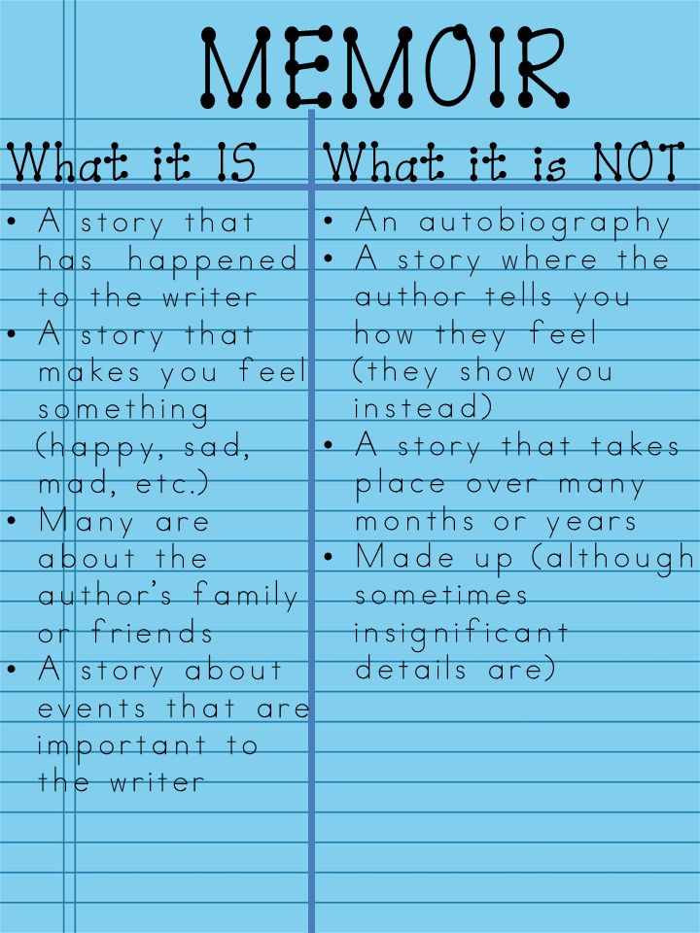

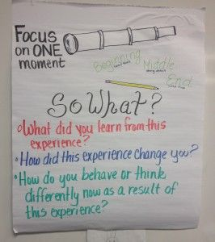

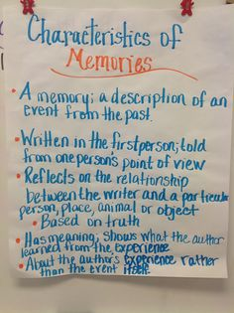
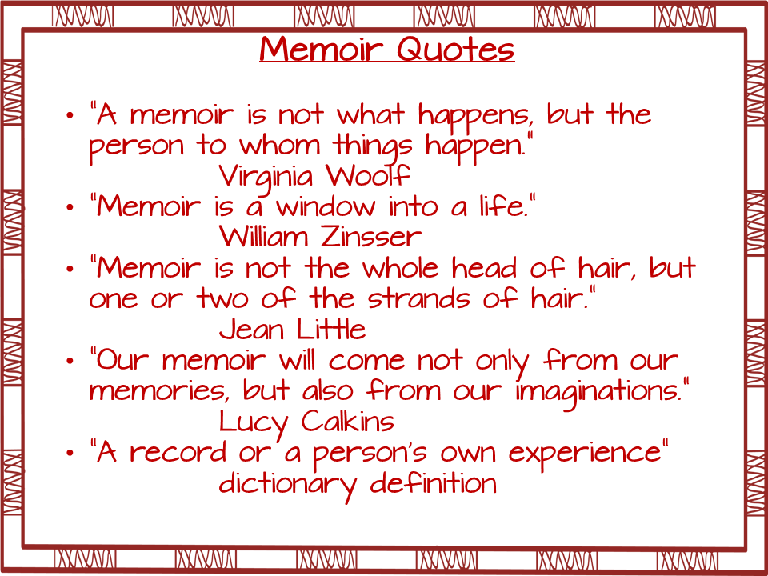
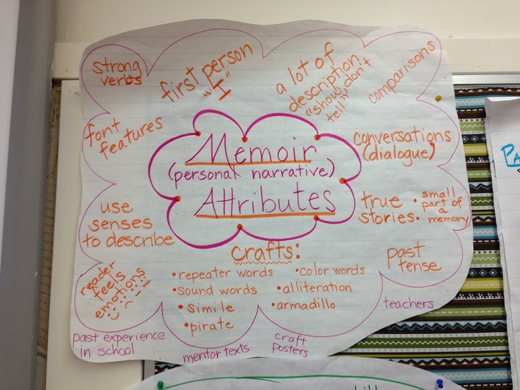
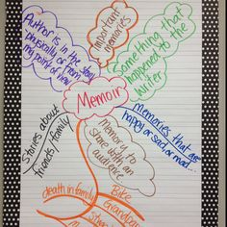

What makes it a memoir?
Title | Is it a memory about a person, place, object, or event? | Does the story make you feel something? | Is the story something that happened to the author? | Is the story something that happened in the past?

Ordinary to Extraordinary Memories

Extraordinary Memory
Ordinary Memory

Laminack describes every direction the boy took the bike and everything he had to do along the way. The book says, “Every Saturday I coasted over the black hose by the gas pumps.

Laminack describes every detail that the boy and Mawmaw did to make the teacakes. “Mammaw dipped a china teacup into the canister of flour, scooped out a cupful, and skimmed over the top with her finger.”
Example:

The boy rides a bicycle.

The boy cooks.

Memoir versus Personal Narrative
A memoir is a memory from a person’s life told in 1st person.

In a memoir, a period of time has passed and the person is now ready to reflect on that moment.

A memoir includes the author’s reflection on how the memory makes them feel and why it is important to them.
A personal narrative is story about something that has happened to the person, also written by them.

In a personal narrative, a person is telling a complete story about a memory.

While a personal narrative may tell the complete story about the all the things a child did at their grandparent’s house during the summer, a memoir is going to focus one moment from the trip, such as when the child and the grandfather went fishing. The child will reflect on why that memory is important to them and how it made them feel.

Some similarities between memoir and personal narrative include:
- They both focus on a moment from the child’s life.
- They both discuss an event, person, place, or object that is important.
- They both have lots of description included.

**Possible- Double Bubble Compare and Contrast Map between the two

Poppop-
- Hunting Trip
- Saturday breakfast
Amelia Island-
- Wave rides
- Shark tooth finding

Event
Object
Place
People
Ideas from Memories

Sensory Details
Authors use sensory details to make the reader feel as though they are a part of the story. The author includes descriptions of all elements around them.
Use this organizer to jot down what you saw, heard, smelled, touched, and tasted during this memory.
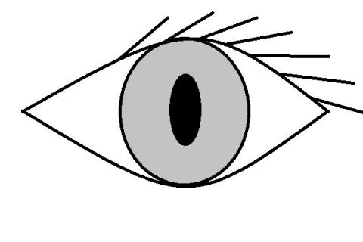
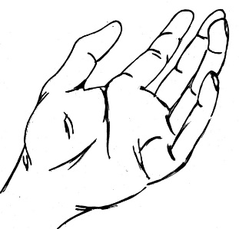
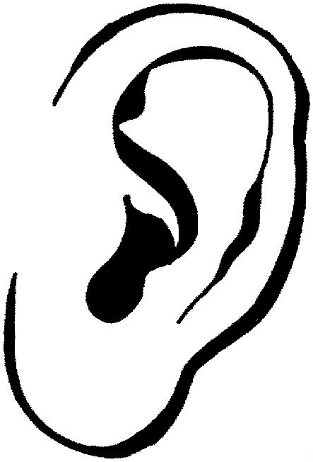
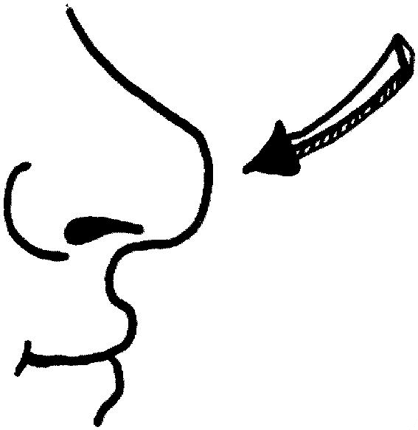

Name _____________________________________ Date________
Timeline for My Memoir

Point 4
Point 5
Next point
How your moment ends or wraps up
(Not the ending of your piece)

Middle point
Next point
How the moment begins
(Not the beginning of your piece)
Point 3
Point 2
Point 1

Going Public
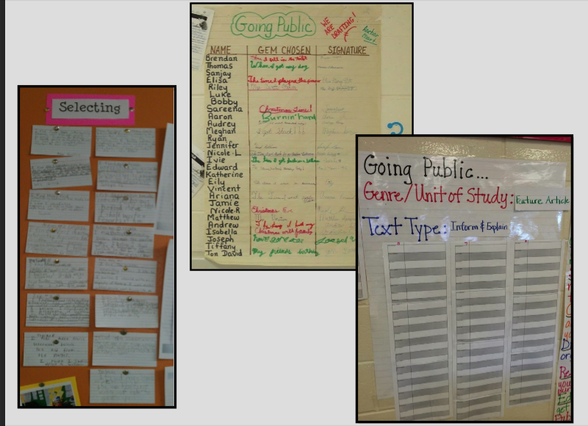

A “Going Public” chart should be present in your classroom for your students to post the idea/memory they choose for their memoir. This will help students stick to their chosen topic and hold them accountable for the piece they are writing. Above are a few examples you can choose from if needed.

I’m Done, Now What?

- Start writing important quotations
- Change the beginnings of your sentences
- Change the length of your sentences
- Sketch an illustration that fits the text
- Grab a mentor text and try something the author did
- Collect similes
- Collect vivid verbs
- Add onomatopoeia
- Add alliteration
- Look for the non-negotiables in your work and edit
- Add details using your 5 senses
- Add internal thinking- hat was I thinking? What was I wondering? What was I feeling?
Action-thinking
Action-wondering
Action-feeling
- Read quietly to a partner to find out what is missing

Transition Words/Phrases for Narrative Writing

After subsequently at first
As soon as first it began
Before second it started
Next once after that
Initially in the meantime during
Now later on at the end
When in the beginning at last
Immediately after a while pretty soon
Meanwhile when we finished soon after
Last the last thing lastly
Later just then
Since before long
Suddenly after ___ minutes
As when we were don
However right after
Whenever in an instant
Soon then

